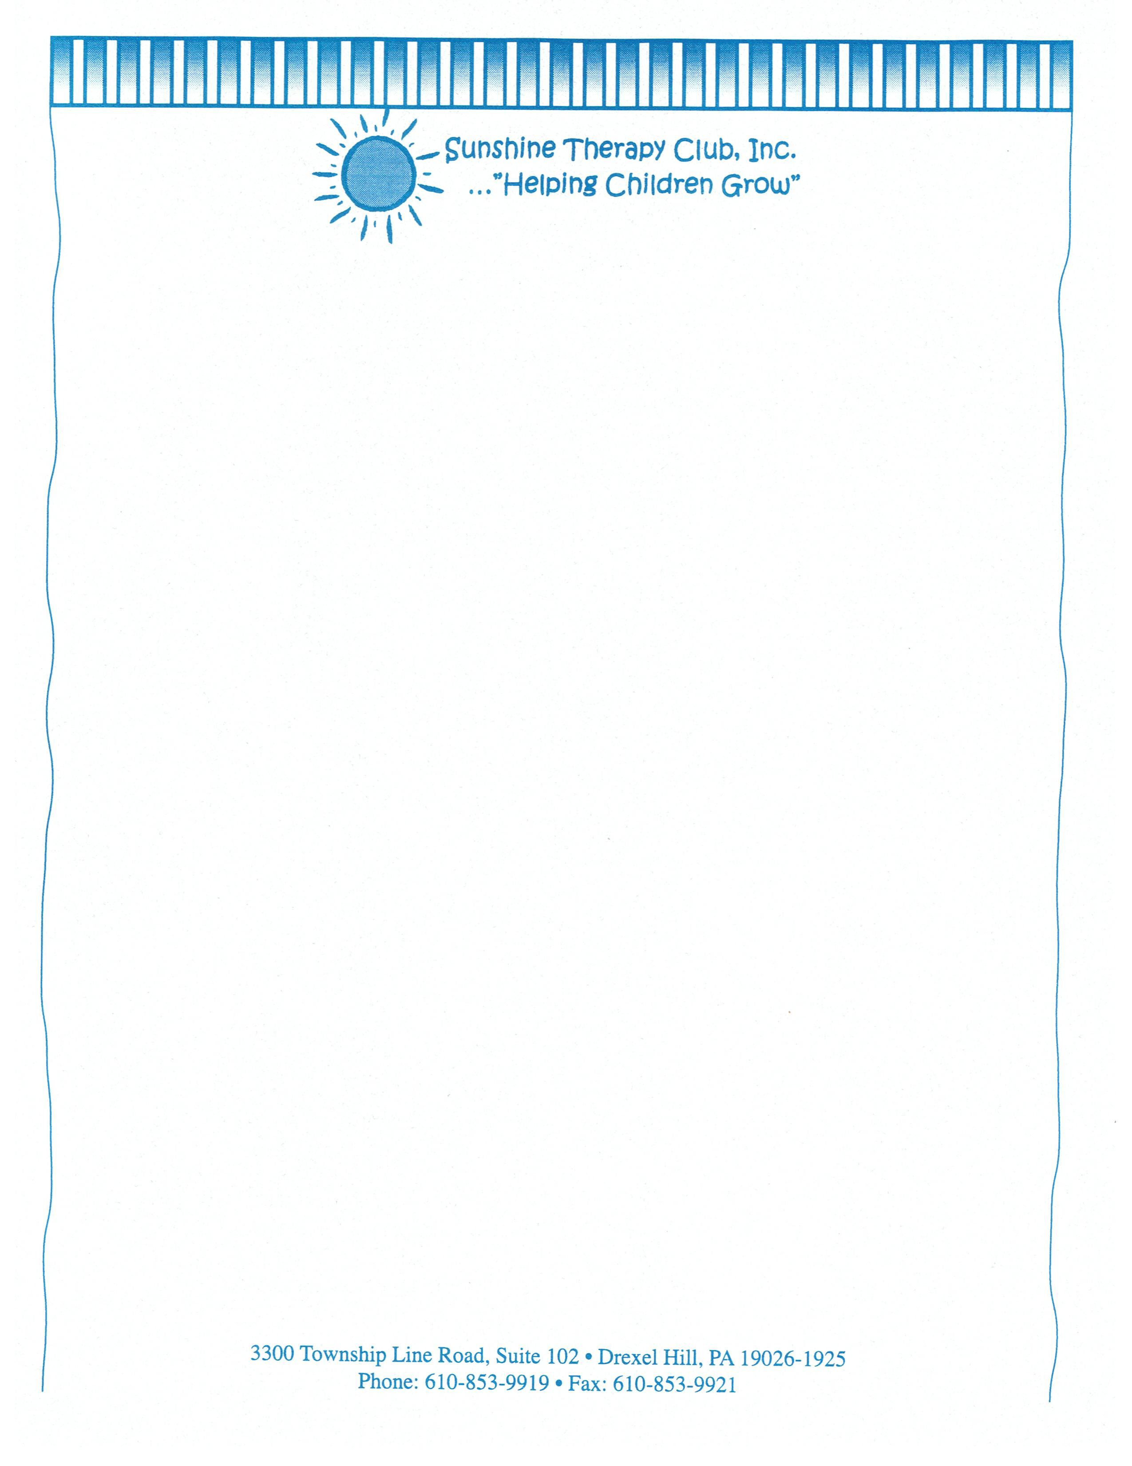

Photographic/Video Release
Please complete one form for each adult and /or child agreeing to be photographed and/or videotaped.

I give my permission for ____________________________________________________________
PRINT NAME (Child’s name)

To be videotaped and for the photographs and/or videotapes to be used for educational purposes only, subjects to be photographed/videotaped will be given a copy of the photograph/videotape.

___________________________________________
PARENT’S NAME (please print)

___________________________________________
PARENT’S SIGNATURE

____________________________________________
DATE

